**Mount Shasta Vision Quest: July 24-30, 1989**

**Surprise Lunch with Two Feathered Friends**

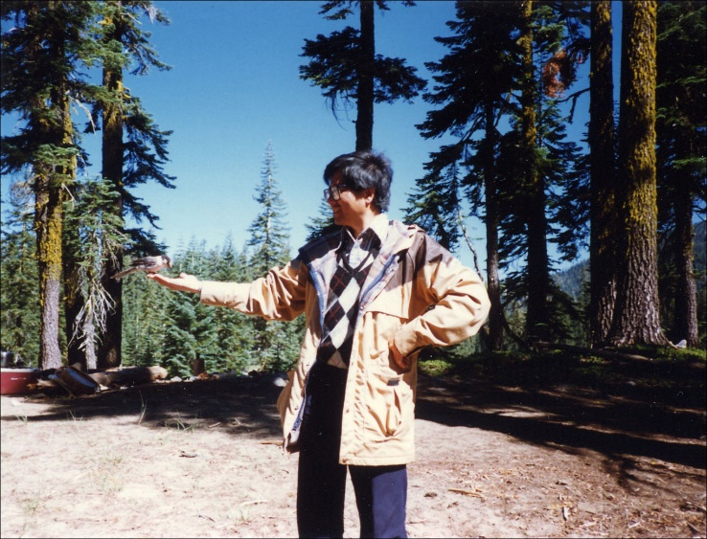

Hammond’s Flycatcher eating sunflower seeds   
 from Peter’s hand at Mt. Shasta camp base, 7-28-1989

*“He Ye! He Ye! He Ye! He Ye! He Ye!”*

Six students in Nina’s journal class chant   
to Mt. Shasta, holding our hands in a circle   
asking the Spirit to bless our vision quest.

Medicine Man Charlie Thom “Redhawk”   
conducts a sweat-lodge ceremony and   
tells me there’s no Indian Bible, picking   
up a handful of dirt— “Our Bible is

Mother Earth and Father Sky as well as   
the wind, the trees, the birds— all part   
of the Great Spirit.” On the fourth day,   
I walk into a forest of tall Douglas firs

and sit on a log for lunch, arranging   
twelve sunflower seeds in a circle nearby.   
*“Treep-treep-treep”*— two gray and white   
Hammond’s flycatchers peck them away.

Now I place raisins and sunflower seeds   
on my left hand— the birds take turns   
flying on my palm, my fingers as their   
landing strip. WOW! I feel so blessed.

One journal writer Robin on seeing this,   
thought I was Saint Francis, and left her

journal on the rock, which we recovered   
the next day. I don’t know if these birds

trailed me to our base camp, for one   
flycatcher flies on my palm again   
and Virginia snapped a photo of   
the birds and me in harmony.

Peter Y. Chou

Mountain View, 9-12-2017

Recounting event of 7-27-1989

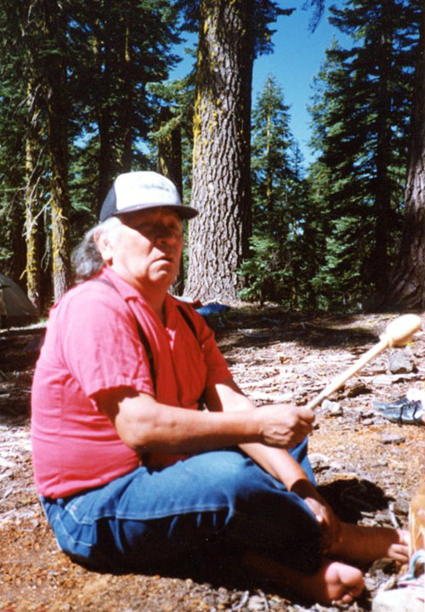

Charlie Thom “Red Hawk”

Mt. Shasta Medicine Man

talking to our Journal group

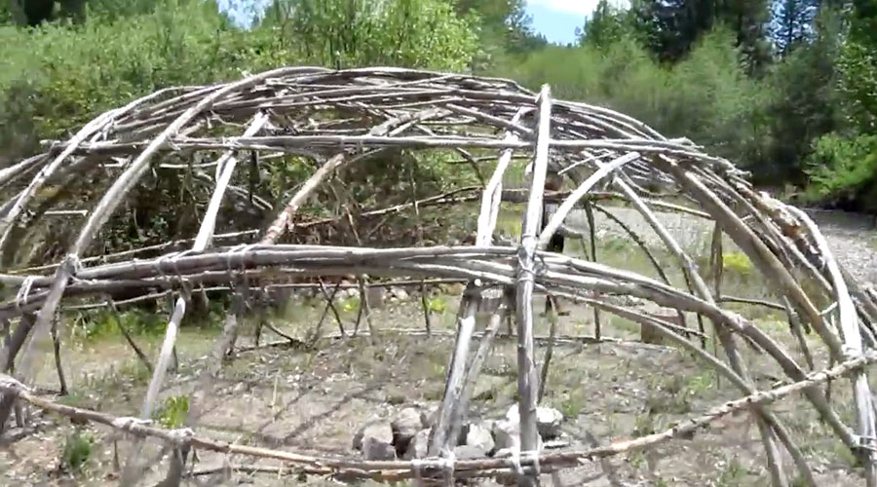

Particiated in Sweat Lodge Ceremony

conducted by Hurak Elder “Red Hawk”

at Mt. Shasta’s Medicine Walk (July 1989)

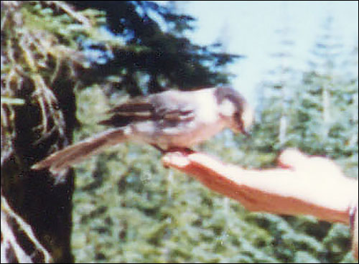

Close-up of bird eating from   
 Peter’s hand (July 28, 1989)

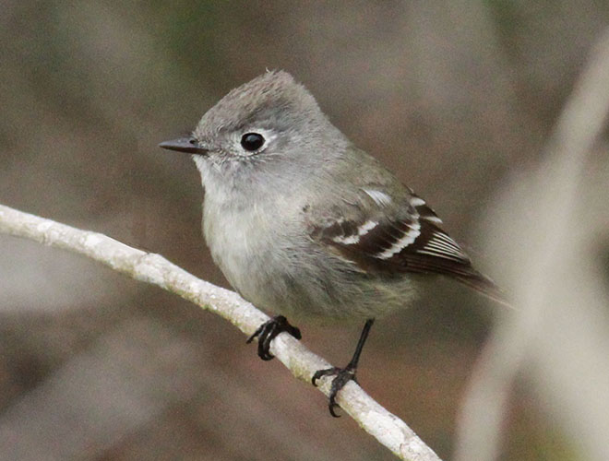

Hammond’s Flycatcher   
 flew to my hand during hike  
 for raisins & sunflower seeds