**Supermoon: November 14, 2016**

Do you see the beauty

of it all?— flakes of light

streaming out of the mouth

of the bright Supermoon.

Not scattered at random   
these light-flakes cascade   
down in a triangular array—   
Do you count 20 of them?

Sparks of Platonic Lambda   
“Soul of the Universe” —

No wonder the Full Moon   
symbolizes Enlightenment.

This Supermoon is special   
as it’s the closest to Earth   
in 68 years— 14% larger   
and 30% brighter than usual.

*New York Times* writes on “Moons   
That Are Super in Their Own Ways” —

Black Moon, Blue Moon, Blood Moon,

Strawberry Moon & Harvest Moon.

I’m still stunned by the photo of  
Lambda-light-flakes projected by   
the Chrysler Building whose apex   
appears as opening in the Moon   
  
running wild tonight flooding   
my mind with that fullness—

*“Let my eye be single so*

*my body shall be full of light”*

* Peter Y. Chou

Mountain View, 12-20-2016

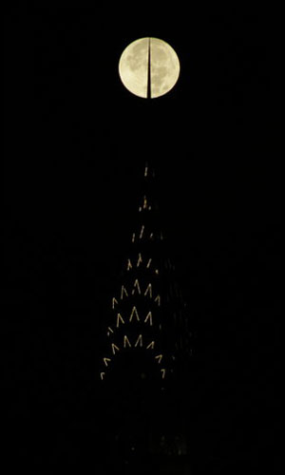

Mike Kentrianakis: November 14, 2016

“Supermoon & Chrysler Building, NYC”